Focus/ visit: | Factors to consider:
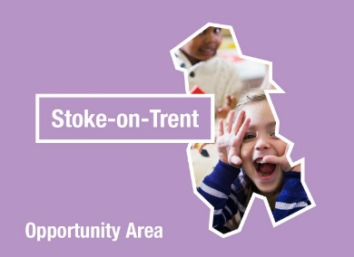
Understanding the World: The World | Understanding the World: People & Communities

Opportunities or experiences to offer before the visit: | Opportunities to offer during the visit: | Opportunities to offer after the visit:

Things to take on the trip:

Evaluation:

