Focus/ visit: Add where you are planning to go | Factors to consider: What things might you have to think about? This may include water safety, road crossing, things to do if public transport takes time to arrive etc.
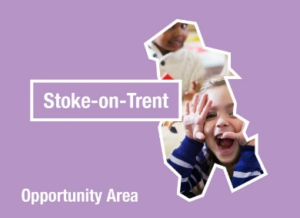
Understanding the World: The World | Understanding the World: People & Communities
Highlight which aspects of this strand the children will experience on the trip. | Highlight which aspects of this strand the children will experience on the trip.

Opportunities or experiences to offer before the visit: |  | Opportunities to offer during the visit: | Opportunities to offer after the visit:
Record what will be offered to the children as preparation for the visit e.g stories shared, risk assessment conversations, enhancements to continuous provision finding out what children already know or want to learn etc. |  | Record what will be done whilst on the visit. This may be on the journey as well at the destination. | Record the types of experiences children will be offered after the trip to help embed understanding, re-create the experience for the children, and to refine their thinking.
Things to take on the trip: | Record anything you might want to take e.g camera, photographs for identifying fetures etc.

Evaluation: What was the impact, what was successful, what you might do differently next time, etc

